DATA PRE-PROCESSING - EXCEL
COMMON CLEANING DONE IN ALL TABLES:
Removed Duplicates from all tables
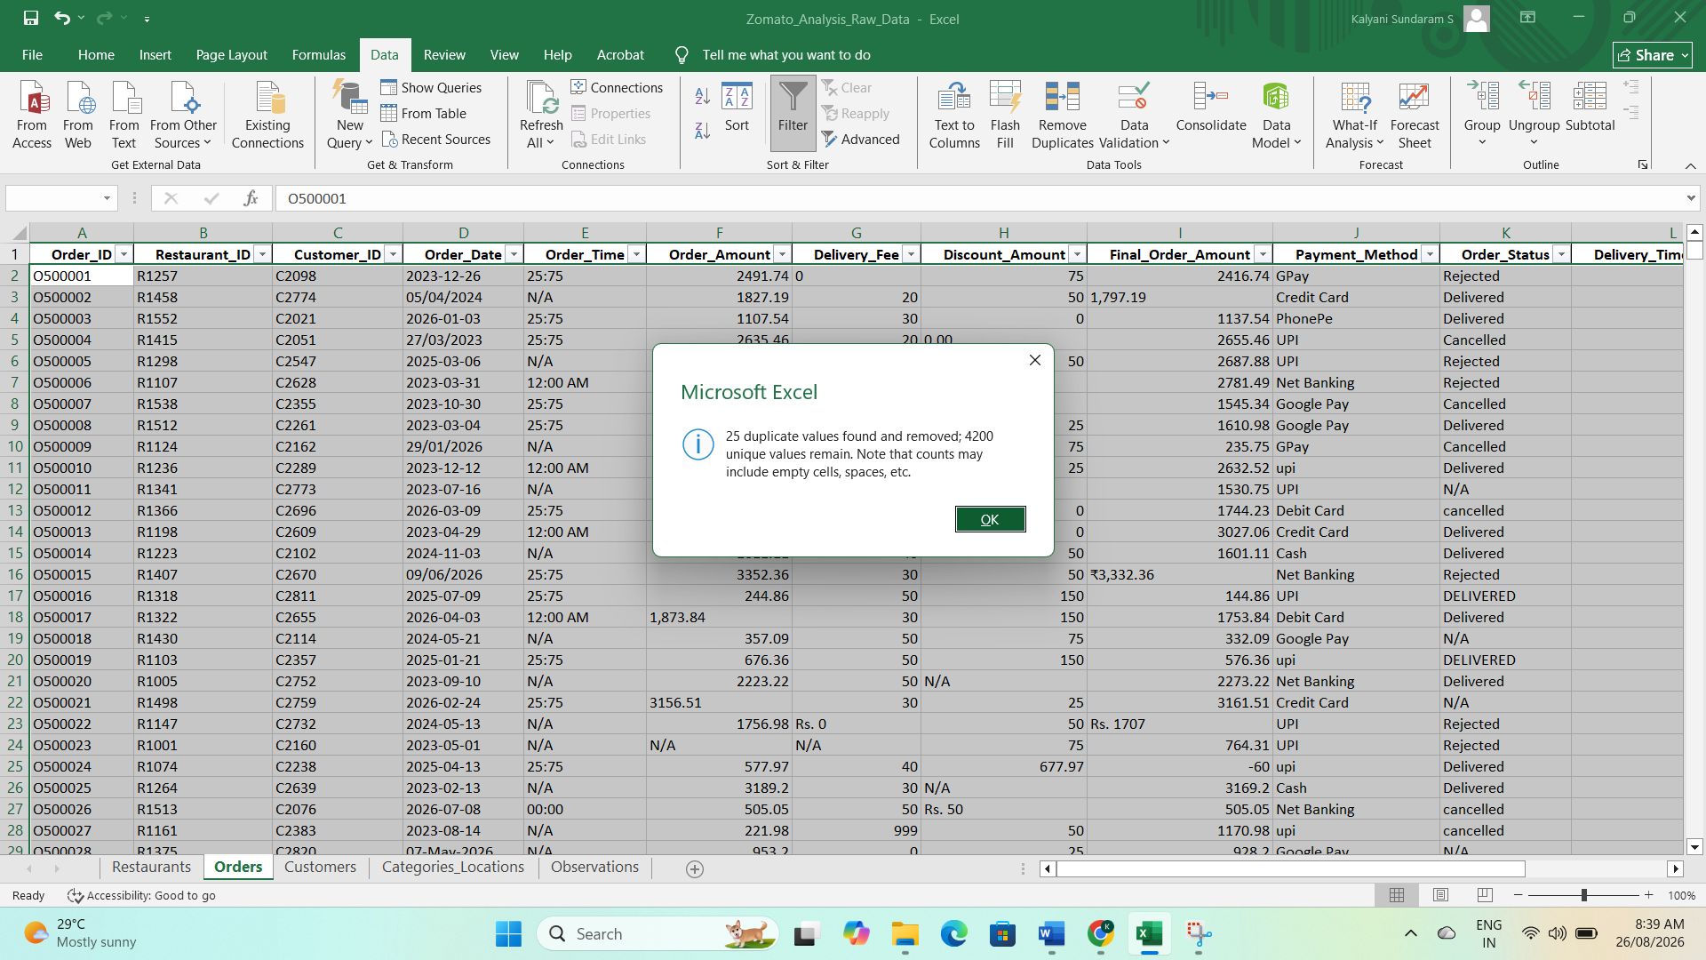
Handled null values using AVERAGEIF, AVERAGE and MODE using Power Query
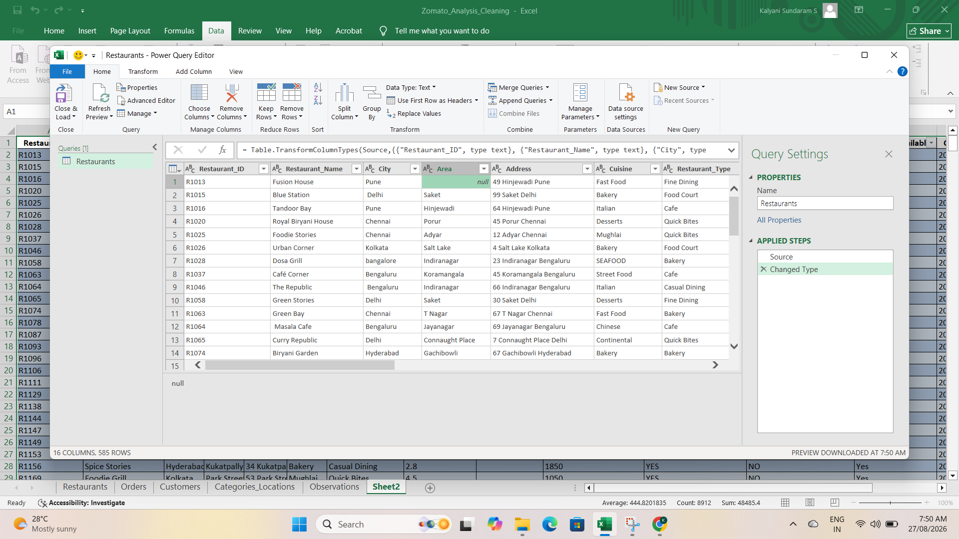
PRE-PROCESSING | TABLE NAME – RESTAURANT
- Missing Restaurant name renamed as unknown
- Missing Restaurant type was filled by finding Mode
- Missing Average_rating was filled by calulating the Average
- Missing Total_Reviews was calculated by finding Average
- Missing Average_cost_for_two was calculated by finding Average
- Created a New Area column. Areas taken from address where areas are null
- Null Address was filled using Area and City Columns as below
- Null City was filled using Address Column
Attached some of the screenshots when Pre-processing is done in Restaurant Table
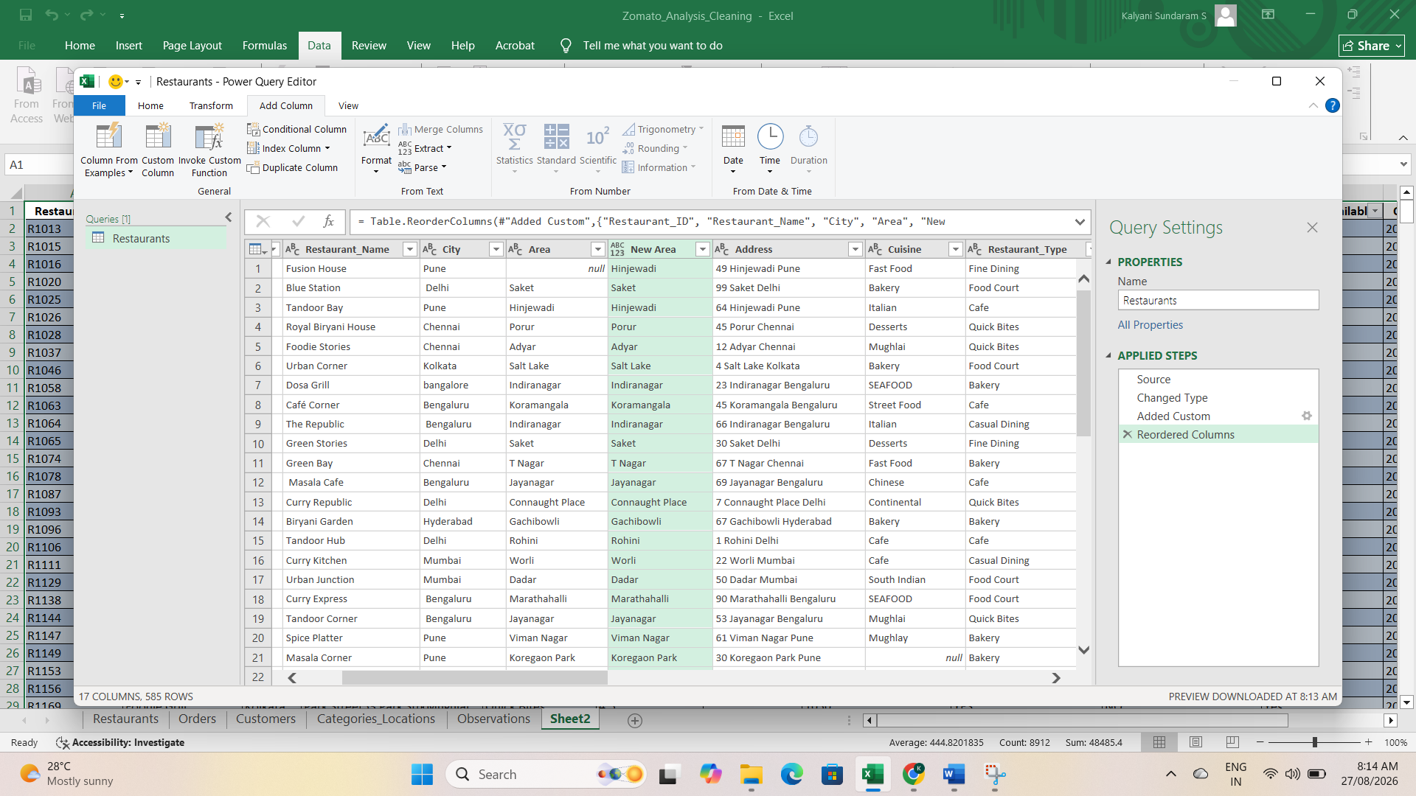
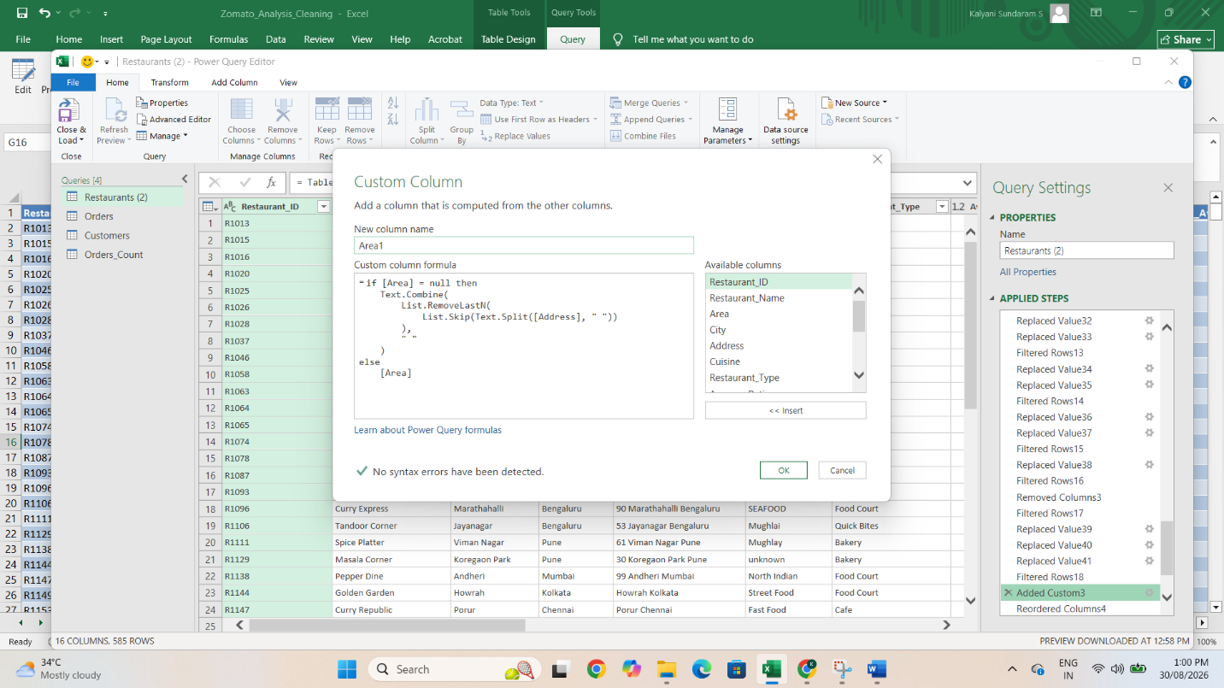

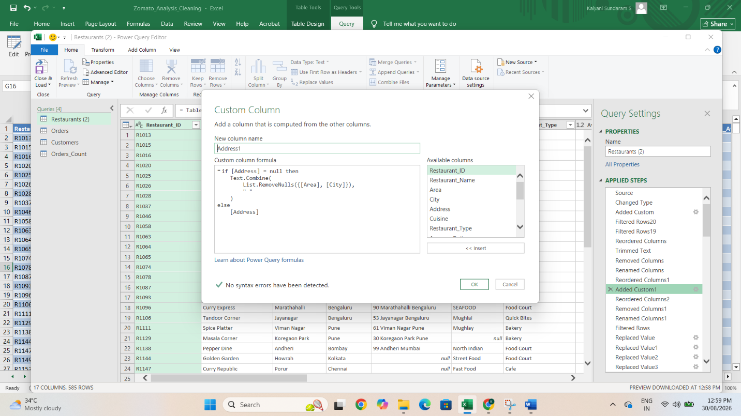
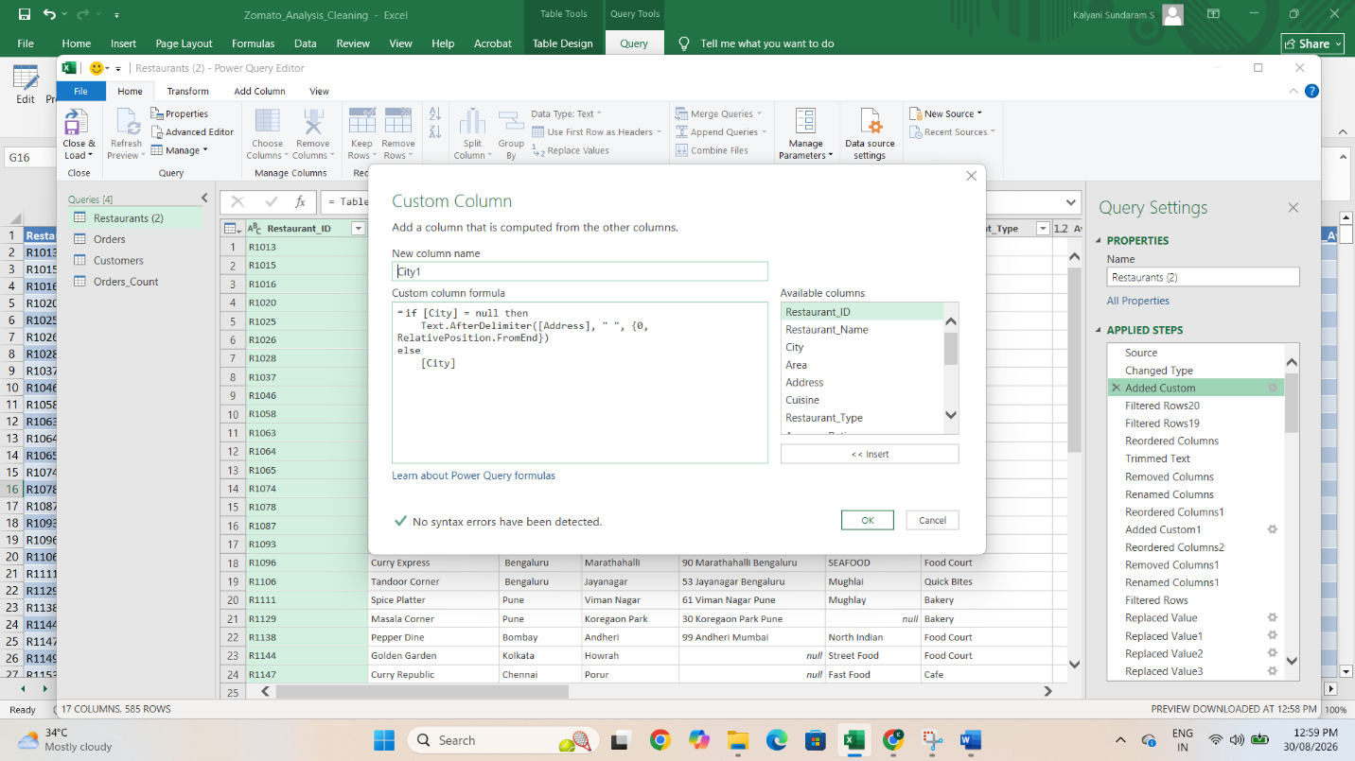
PRE-PROCESSING | TABLE NAME – ORDERS
- 25 duplicate values was removed by selecting all columns
- Removed NULL, NA, N/A, - from all cells and kept blank to fill using power query
- Used Text to Columns to convert the text format to number in Columns Order amount, delivery fee, discount, Final Order amount, Order time
- Using Power Query Replaced null values in the following Columns
Order date, Order amount, delivery fee, discount,Order Status,Delivery time, Customer rating by finding average and Mode
Attached some of the screenshots when Pre-processing is done in Orders Table

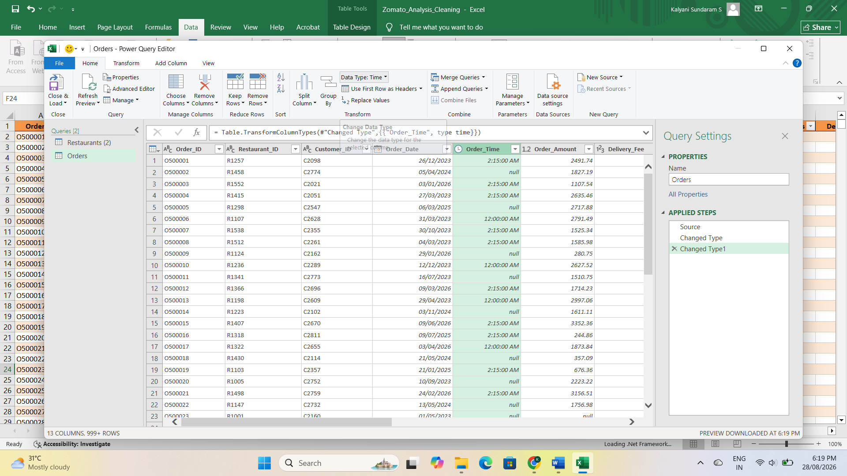
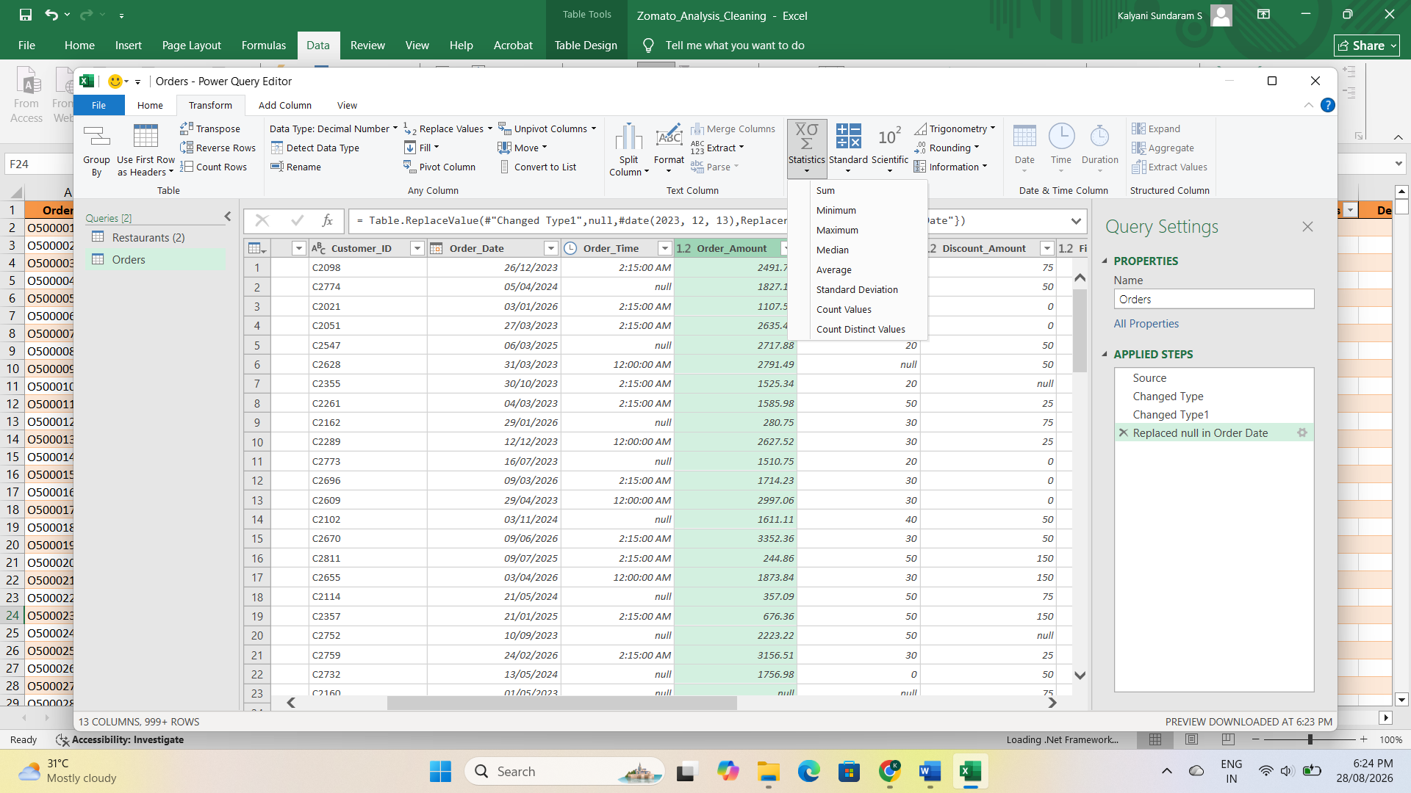

PRE-PROCESSING | TABLE NAME – CUSTOMERS
- 20 duplicate values was removed by selecting all columns
- Removed NULL, NA, N/A, - from all cells and kept blank to fill using power query
- Using Power Query Replaced null values in the following Columns - City,Age by finding average and Mode
- In Gender nulls are replaced with Not willing to Disclose
- Null Customer name replaced with the name Zomato User
- Total order was taken from the Orders table by using Count and merge table by using Left Join
Attached some of the screenshots when Pre-processing is done in Orders Table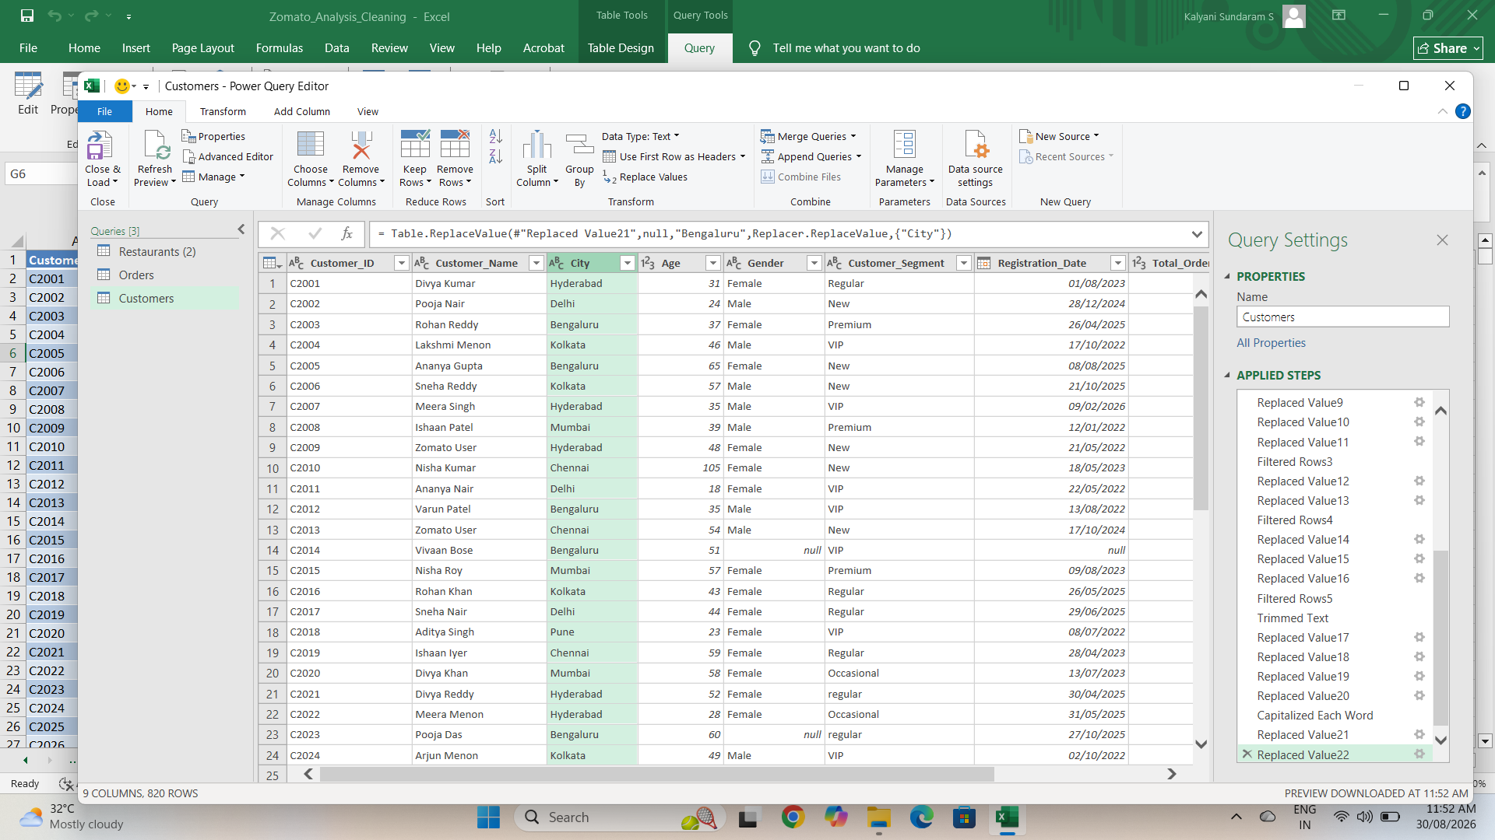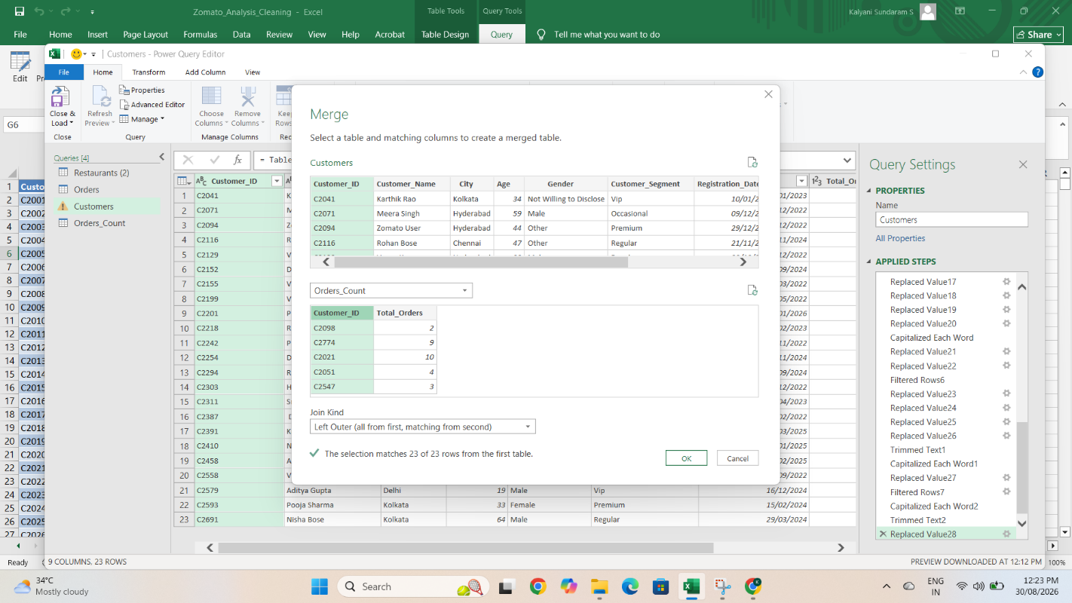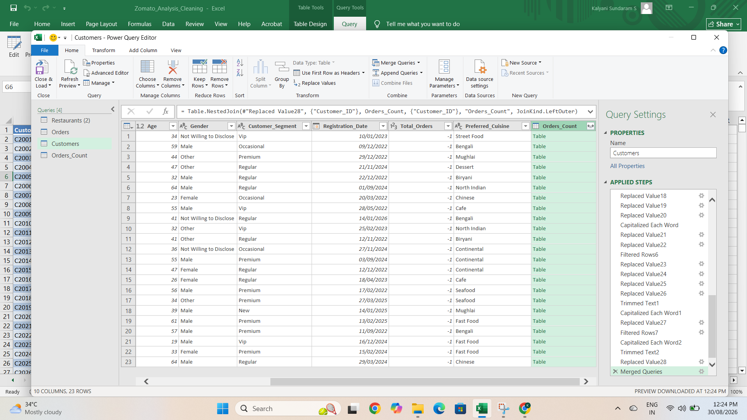

PRE-PROCESSING | TABLE NAME – CATEGORIES_LOCATIONS
- 5 duplicate values was removed by selecting all columns
- Removed NULL, NA, N/A, - from all cells and kept blank to fill using power query
- Replaced null Price Category by finding Mode
Attached some of the screenshots when Pre-processing is done in Categories_Locations Table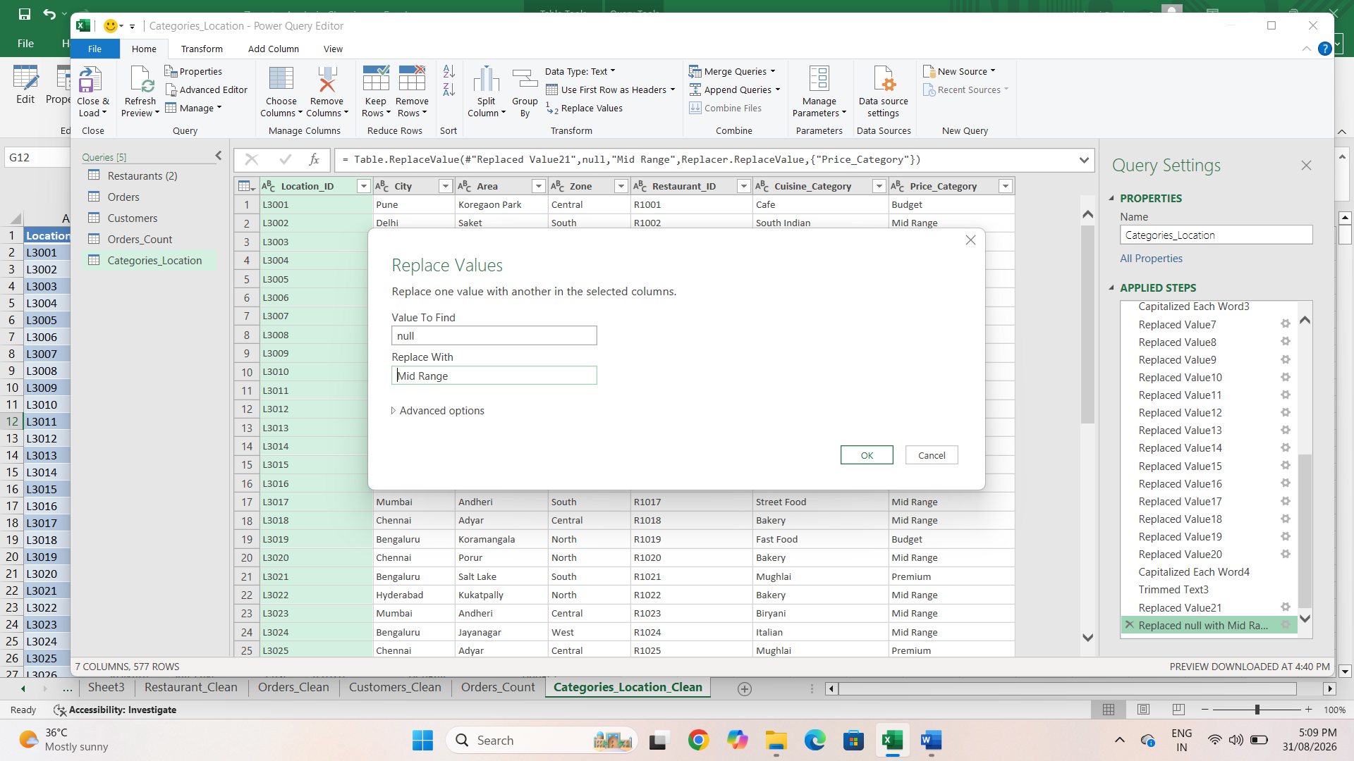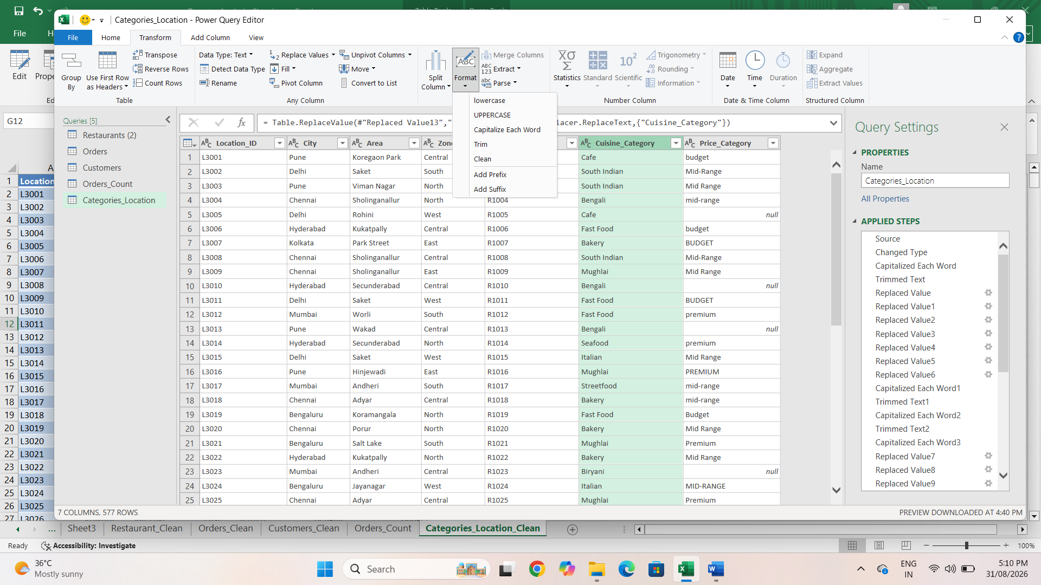
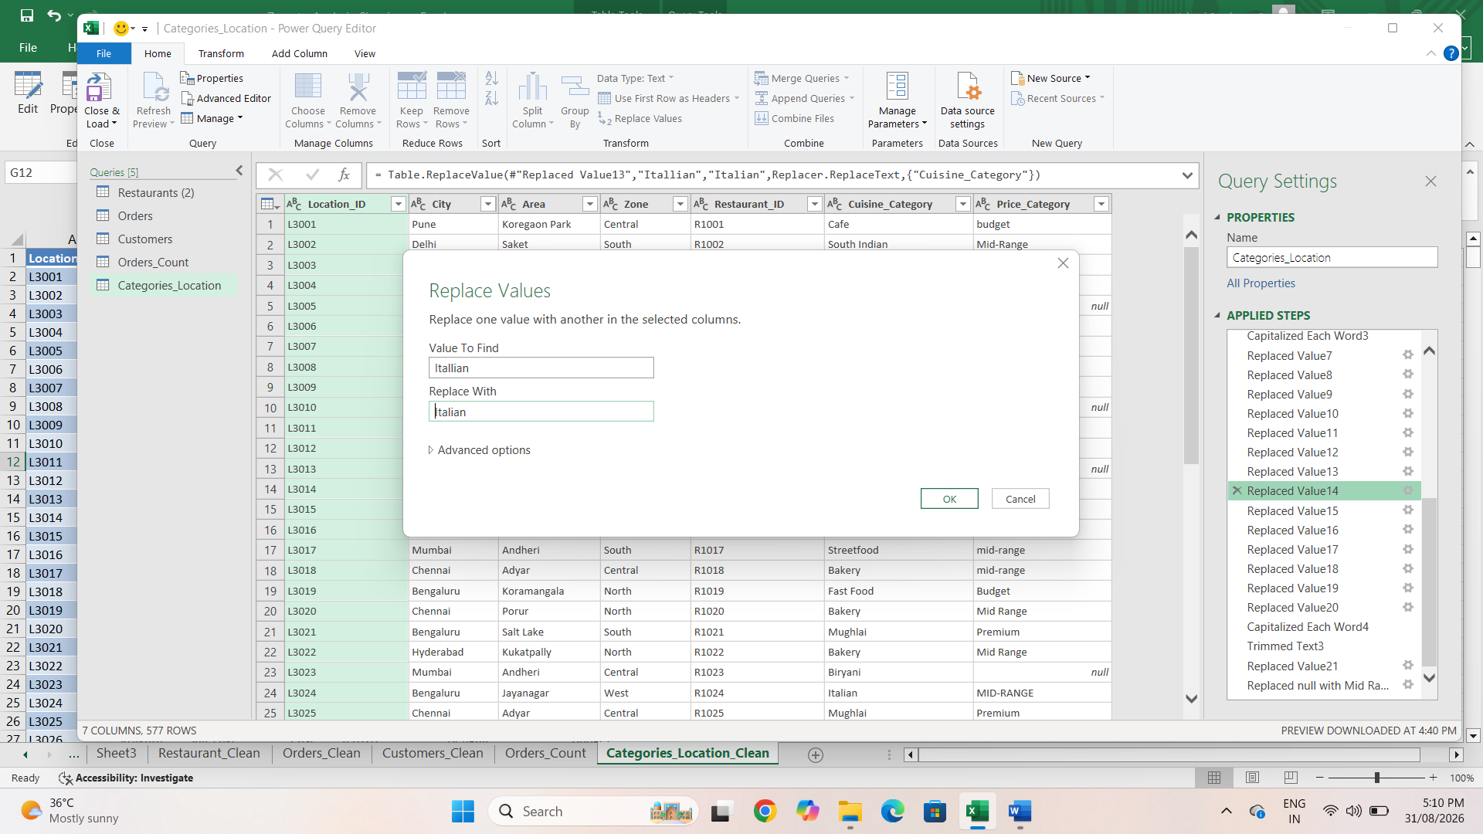

PIVOT TABLE:
Pivot Table is created as below
